MALTA ASYLUM TRENDS

2015

Arrivals

Around **1,677** individuals who applied for asylum in Malta ar­rived through regular means. A high number of non- boat asylum applicants are from Libya and Syria.

A further **104** individuals arrived to Malta either by boat or airlifted be­cause of a medical emergency.

**■ Total arrivals: 1,781**

Figure includes boat and non-boat arrival

Libya (53%)

**Regional Overview**

**1,015,078** arrived in  
Europe by Sea.

**3,771** died/missing in 2015.

85% of arrivals come from  
Syria, Eritrea, Afghanistan  
and Iraq.

Reception

Ethiopia 18%

**Around 600** asylum seekers,

Around 15 persons were held in detention as end of 2015.

At the end of 2015, the Mal­tese Government issued a ‘strategy for the reception of asylum seekers and irregular migrants' ending automatic and mandatory detention for all asylum seekers.

beneficiaries of protection and migrants resides in the **open centres**.

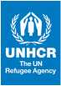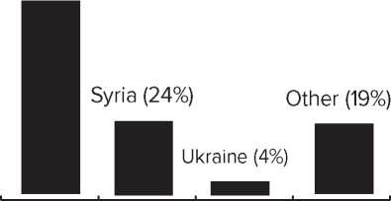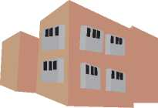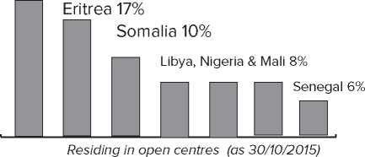

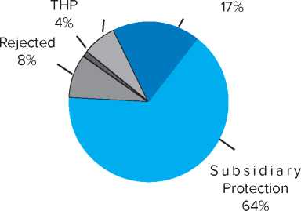

Closed 6% Refugee Status

Protection

81%

of all asylum seekers were granted international **protection** in Malta. A further 4% were granted complementary forms of protection.

1,692 asylum applications were lodged with the Office of the Refu­gee Commission in 2015

International Protection by nationality: (Refugee Status + Subsidiary Protection)

**Libya 68%**

**Some 1,795** asylum applications were decided by the Office of the Refugee Commission in 2015. Numbers reflect first time asylum applications.

Syria 19%

Other 13% U Qj

The Refugee Appeals Board received 295 appeal application as end of year. 11 individu­als were granted international protection.

Solutions

UNHCR estimates that less than **30%** of the over 19,000 individuals who arrived by boat since 2002 remain in Malta.

Beneficiaries of protection have a right to travel doc­uments and many opt to leave the country on their own initiative. Some are transferred back to Malta under the Dublin Regulation framework.

* **568** refugees were **resettled** to the United States of America in 2015.

Around 3,830 beneficiaries of protection have been resettled/relocated since 2005 to the U.S. and the E.U.

* **12** individuals have returned home in 2015 through the Assisted Voluntary Return and Sustainable Re­integration in the Country of Origin programme. 466 individuals returned home through **voluntary repatriation** programmes between 2009 and 2014.

**Source:** Immigration Police, Office of the Refugee Commissioner, Refugee Appeals Board, AWAS, IOM, National Statistics Office, UNHCR. For the official statistics please contact the relevant authorities.  
While every effort has been made to ensure that all statistical information is accurately presented, for official statistics please refer to the original sources. All figures are rounded up.

[www.unhcr.org.mt](http://www.unhcr.org.mt)

Glossary

A Refugee according to the 1951 Convention (and also Maltese legislation) is a person who owing to a well-founded fear of being persecuted for reasons of race, religion, nationality, membership of a particular social group or political opinion, is outside the country of his nationality or habitual residence and is not able to, or because of such fear, is not willing to avail himself of the protection of that country.

Subsidiary Protection is a form of complimentary protec­tion given to those persons who, if returned to their country of origin, would suffer serious harm (death penalty or execution; torture or in­human and degrading treatment/punishment; threat to life or person by reason of indiscriminate violence in situations of international or internal armed conflict).

An Asylum-Seeker is a person who is seeking international protection. In countries with individualized procedures, an asylum­seeker is someone whose claim has not yet been finally decided on by the country in which he or she has submitted it. Not every asylum­seeker will ultimately be recognized as a refugee (or given another form of protection), but every refugee is initially an asylum-seeker.

Detention Detention is a restriction on freedom of movement, usually through enforced confinement and utilized as a last resort. The Maltese Government issued a ‘strategy for the reception of asy­lum seekers and irregular migrants' ending automatic and mandatory detention for all asylum seekers.

UNHCR does not consider it appropriate for any country to detain all asylum seekers who arrive without entry documents.

For more on this point refer to the Guidelines on the Applicable Cri­teria and Standards relating to the Detention of Asylum-Seekers and Alternatives to Detention (2012), available at: [www.unhcr.org.mt](http://www.unhcr.org.mt) or [www.refworld.org](http://www.refworld.org)

Durable Solutions: Any means by which the situation of ref­ugees can be satisfactorily and permanently resolved to enable them to live normal lives. UNHCR traditionally pursues three durable solu­tions: voluntary repatriation, local integration and resettlement.

Migrant: No universally accepted definition for “migrant” exists. The term migrant was usually understood to cover all cases where the decision to migrate was taken freely by the individual concerned for reasons of “personal convenience” and without intervention of an external compelling factor; it therefore applied to persons, and family members, moving to another country or region to better their material or social conditions and improve the prospect for themselves or their family.

Non-Refoulement is a core principle of international law that prohibits States from returning refugees (and also asylum-seekers) in any manner whatsoever to countries or territories in which their lives or freedom may be threatened. The principle of non-refoulement is a rule of customary international law and is therefore binding on all States, whether or not they are parties to the 1951 Refugee Conven­tion.

Unaccompanied and Separated Children are persons below the legal age of majority who are not in the company of an adult who, by law or custom, is responsible for them, such as parents, guardians or primary caregivers.

An Irregular migrant is a person who (a) has entered the territory without a valid visa/document (b) over-stayed his/her visa (c) has remained on the territory despite an expulsion request or order.

A Stateless person is an individual who has no effective na­tionality and therefore cannot benefit from rights deriving from citizen­ship.

Temporary Humanitarian Protection is a form of national protection granted to applicants who do not satisfy the condi­tions for refugee status or subsidiary protection, but who nonetheless should not be returned in view of humanitarian considerations. It may be granted to minors, persons who should not be returned to their country of origin on medical grounds, and persons who should not be returned to their country of origin on other humanitarian grounds. THP affords the beneficiary the same protection as that enjoyed un­der subsidiary protection.

**Such terms should not be used:**

“Illegal Immigrant” - A term widely used in both pub­lic and official discourse to refer to persons who have entered a country without proper visas or identity papers. The term is, however, misleading as in most countries the nature of punish­ment is administrative and not criminal. Also, the 1951 Refugee Convention says that States cannot penalize refugees and asy­lum-seekers just because of unauthorized entry.

“Clandestine” - This term has a strong negative con­notation, invoking a sense of criminality. Sometimes refugees and asylum seekers are often referred as “clandestines” even if they would have permission to remain in the territory of a country.

One can use terms such as “irregular migrants” in­stead of “illegal immigrants”. Other terms, such as “people”, “persons”, “individuals”, “migrants”, “undocumented” might be more neutral. Depending on the case and circumstances, appropriate terms are “refugees”, “asylum-seekers”, “persons seeking protection”.

**UNHCR's general objectives worldwide**

**Monitoring** the access to protection and conditions of asylum in Malta;

**Advocating** for a protection sensitive asylum system and re­lated policies;

**Strengthening** the capacities of government and partner agen­cies;

**Improving** the availability of durable solutions, including through local integration and resettlement or intra-EU reloca­tion;

**Increasing** the general awareness about asylum issues in the country.

Malta is a signatory to the 1951 Convention relating to the Status of Refugees and its 1967 protocol since 1971. It officially lifted its geographical reservation on 13 December 2001. Malta is not yet a signatory to the UN Statelessness Conventions.

**Contact**: UNHCR Malta| 72, Market Street, Floriana, FRN 1080, Malta| mtava@ unhcr.org| +356 2248 9400| WWW.UNHCR.ORG.MT| facebook.com/unhcrmalta| twitter.com/unhcrmalta